GIT &GITHUB -01
What is Git?
- Git is a version control system.
- That means:
- It helps you track changes in your code or files over time
- You can go back to previous versions if something breaks
- Multiple people can work on the same project without overwriting each other’s work
- What is GitHub?
- GitHub is a website/platform that hosts Git repositories online.
- That means:
- It stores your Git projects in the cloud
- You can share your code with others
- Teams can collaborate easily
- It provides extra tools (pull requests, issues, code review, etc.)
- Git init: It is used to initialize a new Git repository in your project folder.
Git status: shows the current state of your Git repository.
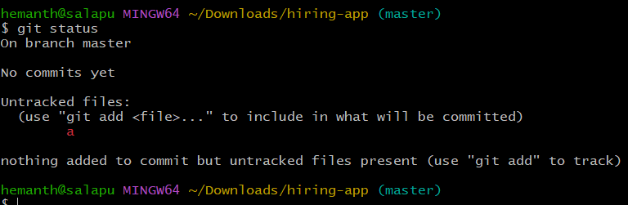
git config –global user.name : Sets your author name for all Git commits
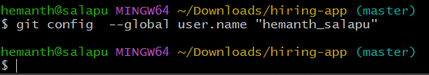
git config –global user.email: This command is used to set your email in Git globally
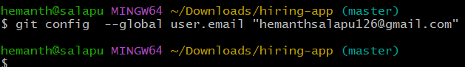
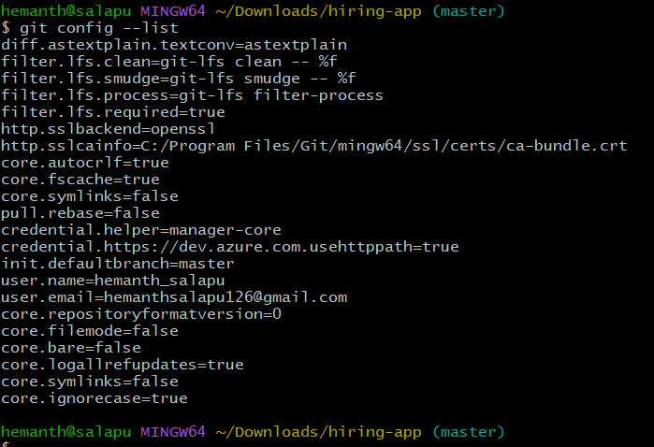
git add filename: It is used to add files to the staging area in Git.
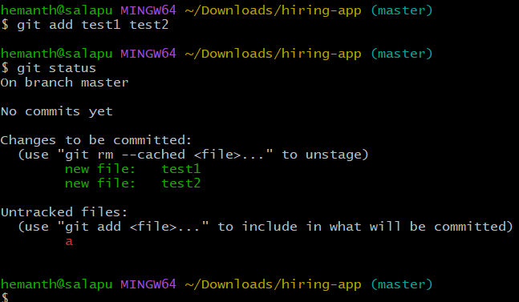
git add filename: It is used to add files to the staging area in Git.
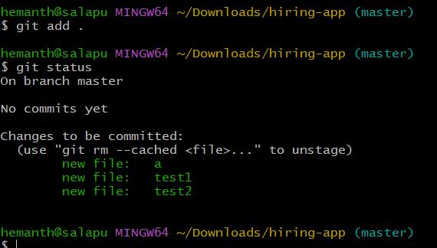
git commit -m "adding files": is used to save (commit) your staged changes
with a massage.
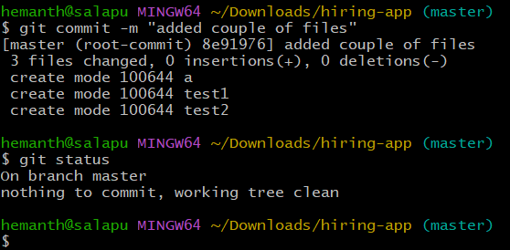

git log: shows the history of commits in your Git repository.
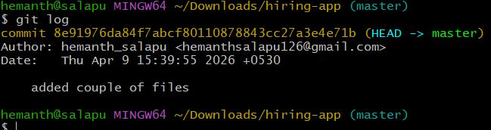
Git remote -v: shows the history of commits in your Git repository.
git remote add origin git remote add origin git@ github.com:hemanthsalapu126-ram/techie-ram.git
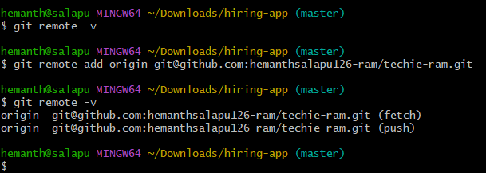
git push -u origin master : is used to upload your local commits to a remote repository
like github
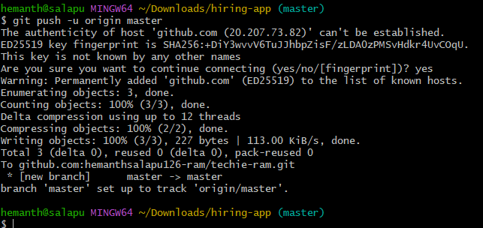
git pull : is used to fetch and download changes from a remote repository (like GitHub) and merge
them into your local branch…
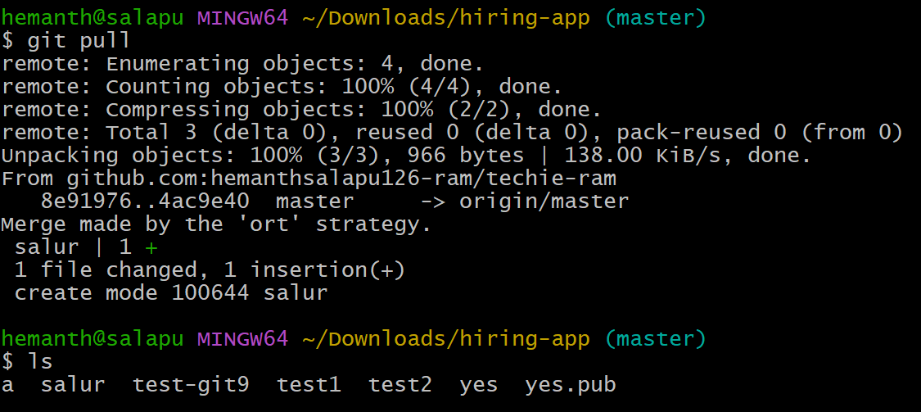
git clone : is used to download a complete copy of a remote repository (from platforms like GitHub)
to your local machine.
